NAMA : ATHIFAH ARSA KHAERAWAN

STAMBUK : 13020180068

KELAS : B1

**TUGAS 11**

**PEMROGRAMAN BERORIENTASI OBJEK**

**PEMBUATAN FORM DATA MAHASISWA**

1. Buat database dan table Database : mahasiswa

Table : tabel_mahasiswa

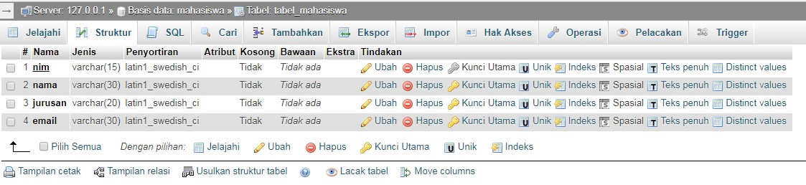

1. Program menghubungkan dengan database import java.sql.Connection; import java.sql.DriverManager;

import java.sql.SQLException;

public class koneksiDB {

private static Connection mysqlconfig;

public static Connection configDB()throws SQLException{ try {

String url="jdbc:mysql://localhost:3306/mahasiswa"; //url database

String user="root"; //user database

String pass=""; //password database

DriverManager.registerDriver(new com.mysql.jdbc.Driver()); mysqlconfig=DriverManager.getConnection(url, user, pass);

} catch (SQLException e) {

System.err.println("koneksi gagal "+e.getMessage()); //perintah menampilkan error pada koneksi

}

return mysqlconfig;

}

}

1. Menambahkan bagian Mysql JDBC driver untuk terhubung dengan database

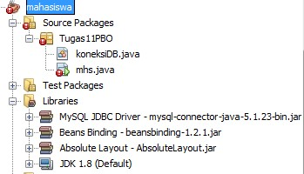

1. Membuat form inputan

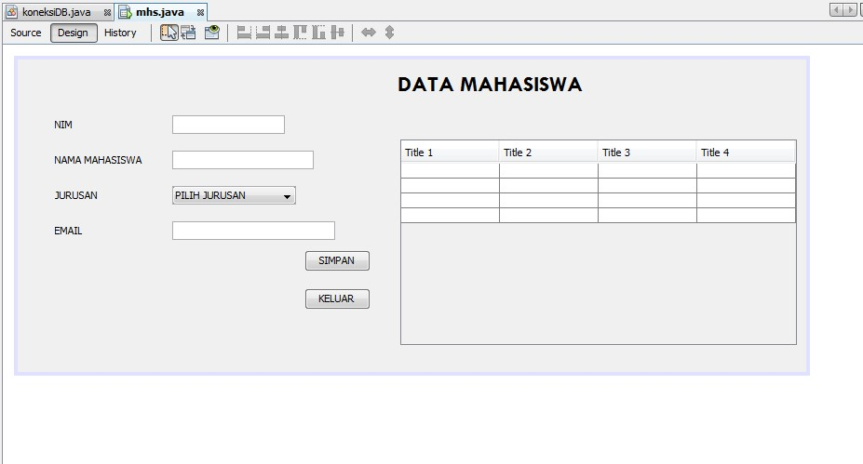

1. Listing form yang telah dibuat **Mhs.java**

import java.sql.Connection; import javax.swing.JTextField;

import javax.swing.table.DefaultTableModel;

/**

*

* @author Dell

*/

public class mhs extends javax.swing.JFrame {

private JTextField txtjurusan; private Object smpn;

public mhs() { initComponents(); load_table(); kosong();

}

private void load_table(){ // membuat tampilan model tabel

DefaultTableModel model = new DefaultTableModel(); model.addColumn("No"); model.addColumn("Nim"); model.addColumn("Nama"); model.addColumn("Jurusan");

model.addColumn("Email");

//menampilkan data database kedalam tabel try { int no=1;

String sql = "select * from tabel_mahasiswa"; java.sql.Connection conn=(Connection)koneksiDB.configDB();

java.sql.Statement stm=conn.createStatement(); java.sql.ResultSet res=stm.executeQuery(sql); while(res.next()){

model.addRow(new

Object[]{no++,res.getString(1),res.getString(2),res.getString(3),res.getString(4 )});

}

tab1.setModel(model); } catch (Exception e) {

}

}

private void kosong(){ txtnim.setEditable(true); txtnim.setText(null); txtnama.setText(null); cbjurusan.setSelectedItem(this); txtemail.setText(null);

}

/**

* This method is called from within the constructor to initialize the form. * WARNING: Do NOT modify this code. The content of this method is always * regenerated by the Form Editor.

*/

private void initComponents() { jLabel1 = new javax.swing.JLabel(); jLabel2 = new javax.swing.JLabel(); jLabel3 = new javax.swing.JLabel(); jLabel4 = new javax.swing.JLabel(); jLabel5 = new javax.swing.JLabel(); txtnim = new javax.swing.JTextField(); txtnama = new javax.swing.JTextField(); txtjurusan = new javax.swing.JTextField();

jScrollPane1 = new javax.swing.JScrollPane();

setDefaultCloseOperation(javax.swing.WindowConstants.EXIT_ON_CLOSE)

;

setBackground(new java.awt.Color(44, 82, 240));

jLabel1.setFont(new java.awt.Font("Times New Roman", 1, 18)); // NOI18N

jLabel1.setText("BIODATA MAHASISWA"); getContentPane().add(jLabel1, new

org.netbeans.lib.awtextra.AbsoluteConstraints(48, 53, 41, 31)); jLabel2.setFont(new java.awt.Font("Tahoma 11 plain", 0, 12)); // NOI18N jLabel2.setText("NIM"); getContentPane().add(jLabel2, new

org.netbeans.lib.awtextra.AbsoluteConstraints(48, 53, 41, 31)); jLabel3.setFont(new java.awt.Font("Tahoma 11 plain", 0, 12)); // NOI18N

jLabel3.setText("NAMA MAHASISWA"); getContentPane().add(jLabel3, new

org.netbeans.lib.awtextra.AbsoluteConstraints(48, 95, 41, 31)); jLabel4.setFont(new java.awt.Font("Tahoma 11 plain", 0, 12)); // NOI18N jLabel4.setText("JURUSAN"); getContentPane().add(jLabel4, new

org.netbeans.lib.awtextra.AbsoluteConstraints(48, 137, 65, 31)); jLabel5.setFont(new java.awt.Font("Tahoma 11 plain", 0, 12)); // NOI18N jLabel5.setText("EMAIL");

getContentPane().add(jLabel5, new

org.netbeans.lib.awtextra.AbsoluteConstraints(48, 179, 50, 31)); getContentPane().add(txtnim, new org.netbeans.lib.awtextra.AbsoluteConstraints(172, 53, 213, 31)); txtnama.addActionListener(new java.awt.event.ActionListener() { public void actionPerformed(java.awt.event.ActionEvent evt) { txtnamaActionPerformed(evt);

}

});

getContentPane().add(txtnama, new

org.netbeans.lib.awtextra.AbsoluteConstraints(172, 95, 213, 31)); getContentPane().add(txtjurusan, new

org.netbeans.lib.awtextra.AbsoluteConstraints(172, 137, 213, 31)); simpan.setText("SIMPAN"); simpan.addActionListener(new java.awt.event.ActionListener() { public void actionPerformed(java.awt.event.ActionEvent evt) { simpanActionPerformed(evt);

}

});

getContentPane().add(simpan, new

org.netbeans.lib.awtextra.AbsoluteConstraints(231, 216, -1, 33)); edit.setText("EDIT"); edit.addActionListener(new java.awt.event.ActionListener() { public void actionPerformed(java.awt.event.ActionEvent evt) { reActionPerformed(evt);

}

});

getContentPane().add(edit, new org.netbeans.lib.awtextra.AbsoluteConstraints(308,

216, -1, 33));

tab1.setModel(new javax.swing.table.DefaultTableModel( new Object [][] {

{null, null, null, null},

{null, null, null, null},

{null, null, null, null},

{null, null, null, null}

},

new String [] {

"Title 1", "Title 2", "Title 3", "Title 4"

}

));

tab1.addMouseListener(new java.awt.event.MouseAdapter() { public void mouseClicked(java.awt.event.MouseEvent evt) { tab1MouseClicked(evt);

}

});

jScrollPane1.setViewportView(tab1); getContentPane().add(jScrollPane1, new

org.netbeans.lib.awtextra.AbsoluteConstraints(48, 260, 337, 93)); hps.setText("HAPUS"); hps.addActionListener(new java.awt.event.ActionListener() { public void actionPerformed(java.awt.event.ActionEvent evt) { edtActionPerformed(evt);

}

});

getContentPane().add(hps, new org.netbeans.lib.awtextra.AbsoluteConstraints(253,

359, -1, 33)); klr.setText("KELUAR"); klr.addActionListener(new java.awt.event.ActionListener() { public void actionPerformed(java.awt.event.ActionEvent evt) { hpsActionPerformed(evt);

}

});

getContentPane().add(, new org.netbeans.lib.awtextra.AbsoluteConstraints(314,

359, -1, 33));

pro.setFont(new java.awt.Font("Tahoma", 0, 12)); // NOI18N

pro.setModel(new javax.swing.DefaultComboBoxModel<>(new String[] { "Teknik

Informatika", "Sistem Informasi" })); pro.setName(""); // NOI18N pro.addActionListener(new java.awt.event.ActionListener() { public void actionPerformed(java.awt.event.ActionEvent evt) { proActionPerformed(evt);

}

});

getContentPane().add(pro, new org.netbeans.lib.awtextra.AbsoluteConstraints(172,

179, 213, 31)); pack();

}// </editor-fold> private void txtnamaActionPerformed(java.awt.event.ActionEvent evt) { // TODO add your handling code here:

}

private void smpnActionPerformed(java.awt.event.ActionEvent evt) { // TODO add your handling code here: try {

String sql = "INSERT INTO tabel_mahasiswa VALUES

('"+txtnim.getText()+"','"+txtnama.getText()+"','"+txtfak.getText()+"','"+pro.getSelectedI t

em()+"')"; java.sql.Connection conn=(Connection)koneksiDb.configDB(); java.sql.PreparedStatement pst=conn.prepareStatement(sql); pst.execute();

JOptionPane.showMessageDialog(null, "Penyimpanan Data Berhasil");

} catch (Exception e) {

JOptionPane.showMessageDialog(this, e.getMessage());

} load_table(); kosong();

}

@SuppressWarnings("unchecked")

// <editor-fold defaultstate="collapsed" desc="Generated Code"> private void initComponents() {

jLabel1 = new javax.swing.JLabel(); jLabel2 = new javax.swing.JLabel(); txtnim = new javax.swing.JTextField(); txtnama = new javax.swing.JTextField(); jLabel3 = new javax.swing.JLabel(); jLabel4 = new javax.swing.JLabel(); cbjurusan = new javax.swing.JComboBox<>();

jLabel5 = new javax.swing.JLabel(); txtemail = new javax.swing.JTextField(); btHapus = new javax.swing.JButton(); btKeluar = new javax.swing.JButton(); jScrollPane1 = new javax.swing.JScrollPane(); tablemahasiswa = new javax.swing.JTable(); btSimpan = new javax.swing.JButton(); btEdit = new javax.swing.JButton();

setDefaultCloseOperation(javax.swing.WindowConstants.EXIT_ON_CLOSE);

jLabel1.setFont(new java.awt.Font("Tw Cen MT", 1, 24)); // NOI18N jLabel1.setText("DATA MAHASISWA"); jLabel1.setName(""); // NOI18N

jLabel2.setText("NIM");

txtnim.addActionListener(new java.awt.event.ActionListener() { public void actionPerformed(java.awt.event.ActionEvent evt) { txtnimActionPerformed(evt);

}

});

txtnama.addActionListener(new java.awt.event.ActionListener() { public void actionPerformed(java.awt.event.ActionEvent evt) { txtnamaActionPerformed(evt);

}

});

jLabel3.setText("NAMA MAHASISWA");

jLabel4.setText("JURUSAN");

cbjurusan.setModel(new javax.swing.DefaultComboBoxModel<>(new String[] { "PILIH JURUSAN", "TEKNIK INFORMATIKA", "SISTEM INFORMASI", " " }));

cbjurusan.addActionListener(new java.awt.event.ActionListener() { public void actionPerformed(java.awt.event.ActionEvent evt) { cbjurusanActionPerformed(evt);

}

});

jLabel5.setText("EMAIL");

txtemail.addActionListener(new java.awt.event.ActionListener() { public void actionPerformed(java.awt.event.ActionEvent evt) { txtemailActionPerformed(evt);

}

});

btHapus.setText("HAPUS");

btHapus.addActionListener(new java.awt.event.ActionListener() { public void actionPerformed(java.awt.event.ActionEvent evt) { btHapusActionPerformed(evt);

}

});

btKeluar.setText("KELUAR"); btKeluar.addActionListener(new java.awt.event.ActionListener() { public void actionPerformed(java.awt.event.ActionEvent evt) { btKeluarActionPerformed(evt);

}

});

tablemahasiswa.setModel(new javax.swing.table.DefaultTableModel( new Object [][] { {null, null, null, null},

{null, null, null, null},

{null, null, null, null},

{null, null, null, null}

},

new String [] {

"Title 1", "Title 2", "Title 3", "Title 4"

}

));

jScrollPane1.setViewportView(tablemahasiswa);

btSimpan.setText("SIMPAN"); btSimpan.addActionListener(new java.awt.event.ActionListener() { public void actionPerformed(java.awt.event.ActionEvent evt) { btSimpanActionPerformed(evt);

}

});

btEdit.setText("EDIT");

btEdit.addActionListener(new java.awt.event.ActionListener() { public void actionPerformed(java.awt.event.ActionEvent evt) { btEditActionPerformed(evt);

}

});

javax.swing.GroupLayout layout = new javax.swing.GroupLayout(getContentPane());

getContentPane().setLayout(layout); layout.setHorizontalGroup(

layout.createParallelGroup(javax.swing.GroupLayout.Alignment.LEADING)

.addGroup(javax.swing.GroupLayout.Alignment.TRAILING, layout.createSequentialGroup()

.addContainerGap(javax.swing.GroupLayout.DEFAULT_SIZE,

Short.MAX_VALUE)

.addComponent(jLabel1)

.addGap(240, 240, 240))

.addGroup(layout.createSequentialGroup()

.addGap(40, 40, 40)

.addGroup(layout.createParallelGroup(javax.swing.GroupLayout.Alignment.LEADING)

.addComponent(jLabel2)

.addComponent(jLabel3)

.addComponent(jLabel4)

.addComponent(jLabel5)

.addComponent(btSimpan)

.addComponent(btEdit))

.addGroup(layout.createParallelGroup(javax.swing.GroupLayout.Alignment.LEADING)

.addGroup(layout.createSequentialGroup()

.addGap(32, 32, 32)

.addGroup(layout.createParallelGroup(javax.swing.GroupLayout.Alignment.LEADING)

.addComponent(cbjurusan,

javax.swing.GroupLayout.PREFERRED_SIZE, javax.swing.GroupLayout.DEFAULT_SIZE,

javax.swing.GroupLayout.PREFERRED_SIZE)

.addComponent(txtnim,

|  |  |
| --- | --- |
| javax.swing.GroupLayout.PREFERRED_SIZE, javax.swing.GroupLayout.PREFERRED_SIZE)  .addComponent(txtnama, | 121, |
| javax.swing.GroupLayout.PREFERRED_SIZE,  javax.swing.GroupLayout.PREFERRED_SIZE)  .addComponent(txtemail, | 152, |
| javax.swing.GroupLayout.PREFERRED_SIZE,  javax.swing.GroupLayout.PREFERRED_SIZE)))  .addGroup(layout.createSequentialGroup()  .addGap(174, 174, 174) | 175, |

.addGroup(layout.createParallelGroup(javax.swing.GroupLayout.Alignment.LEADING)

.addComponent(btHapus)

.addComponent(btKeluar))))

.addPreferredGap(javax.swing.LayoutStyle.ComponentPlacement.RELATED,

32, Short.MAX_VALUE)

.addComponent(jScrollPane1, javax.swing.GroupLayout.PREFERRED_SIZE,

426, javax.swing.GroupLayout.PREFERRED_SIZE)

.addContainerGap())

);

layout.setVerticalGroup(

layout.createParallelGroup(javax.swing.GroupLayout.Alignment.LEADING)

.addGroup(layout.createSequentialGroup()

.addContainerGap()

.addComponent(jLabel1, javax.swing.GroupLayout.PREFERRED_SIZE, 31, javax.swing.GroupLayout.PREFERRED_SIZE)

.addGap(18, 18, 18)

.addGroup(layout.createParallelGroup(javax.swing.GroupLayout.Alignment.BASELINE

)

.addComponent(jLabel2)

.addComponent(txtnim, javax.swing.GroupLayout.PREFERRED_SIZE, javax.swing.GroupLayout.DEFAULT_SIZE, javax.swing.GroupLayout.PREFERRED_SIZE))

.addGroup(layout.createParallelGroup(javax.swing.GroupLayout.Alignment.LEADING)

.addGroup(layout.createSequentialGroup()

.addGap(18, 18, 18)

.addGroup(layout.createParallelGroup(javax.swing.GroupLayout.Alignment.BASELINE

)

.addComponent(txtnama,

javax.swing.GroupLayout.PREFERRED_SIZE, javax.swing.GroupLayout.DEFAULT_SIZE,

javax.swing.GroupLayout.PREFERRED_SIZE)

.addComponent(jLabel3))

.addGap(18, 18, 18)

.addGroup(layout.createParallelGroup(javax.swing.GroupLayout.Alignment.BASELINE

)

.addComponent(cbjurusan,

javax.swing.GroupLayout.PREFERRED_SIZE, javax.swing.GroupLayout.DEFAULT_SIZE,

javax.swing.GroupLayout.PREFERRED_SIZE)

.addComponent(jLabel4))

.addGap(18, 18, 18)

.addGroup(layout.createParallelGroup(javax.swing.GroupLayout.Alignment.BASELINE

)

.addComponent(jLabel5) .addComponent(txtemail,

javax.swing.GroupLayout.PREFERRED_SIZE, javax.swing.GroupLayout.DEFAULT_SIZE,

javax.swing.GroupLayout.PREFERRED_SIZE))

.addPreferredGap(javax.swing.LayoutStyle.ComponentPlacement.UNRELATED)

.addGroup(layout.createParallelGroup(javax.swing.GroupLayout.Alignment.BASELINE

)

.addComponent(btHapus)

.addComponent(btSimpan))

.addGap(18, 18, 18)

.addGroup(layout.createParallelGroup(javax.swing.GroupLayout.Alignment.BASELINE

)

.addComponent(btKeluar)

.addComponent(btEdit))

.addContainerGap(javax.swing.GroupLayout.DEFAULT_SIZE,

Short.MAX_VALUE))

.addGroup(javax.swing.GroupLayout.Alignment.TRAILING, layout.createSequentialGroup()

.addPreferredGap(javax.swing.LayoutStyle.ComponentPlacement.RELATED,

javax.swing.GroupLayout.DEFAULT_SIZE, Short.MAX_VALUE)

.addComponent(jScrollPane1,

javax.swing.GroupLayout.PREFERRED_SIZE, 221, javax.swing.GroupLayout.PREFERRED_SIZE)

.addGap(29, 29, 29))))

);

jLabel1.getAccessibleContext().setAccessibleName("");

getAccessibleContext().setAccessibleName("Aplikasi Data Mahasiswa");

pack();

setLocationRelativeTo(null);

}// </editor-fold>

private void txtnimActionPerformed(java.awt.event.ActionEvent evt) { // TODO add your handling code here:

}

private void btKeluarActionPerformed(java.awt.event.ActionEvent evt) { // TODO add your handling code here:

system.exit(0);

}

private void txtnamaActionPerformed(java.awt.event.ActionEvent evt) { // TODO add your handling code here:

}

private void cbjurusanActionPerformed(java.awt.event.ActionEvent evt) { // TODO add your handling code here:

}

private void txtemailActionPerformed(java.awt.event.ActionEvent evt) { // TODO add your handling code here:

}

private void btSimpanActionPerformed(java.awt.event.ActionEvent evt) { // TODO add your handling code here:

}

private void btEditActionPerformed(java.awt.event.ActionEvent evt) { // TODO add your handling code here:

}

private void btHapusActionPerformed(java.awt.event.ActionEvent evt) { // TODO add your handling code here:

}

public static void main(String args[]) { java.awt.EventQueue.invokeLater(new Runnable() { public void run() {

new mhs().setVisible(true);

}

});

}

// Variables declaration - do not modify

private javax.swing.JButton btEdit; private javax.swing.JButton btHapus; private javax.swing.JButton btKeluar; private javax.swing.JButton btSimpan; private javax.swing.JComboBox<String> cbjurusan;

private javax.swing.JLabel jLabel1; private javax.swing.JLabel jLabel2; private javax.swing.JLabel jLabel3; private javax.swing.JLabel jLabel4; private javax.swing.JLabel jLabel5; private javax.swing.JScrollPane jScrollPane1; private javax.swing.JTable tablemahasiswa; private javax.swing.JTextField txtemail; private javax.swing.JTextField txtnama; private javax.swing.JTextField txtnim;

// End of variables declaration

}

6. Hasil run program

